# SSL configuration at server side(apache tomcat server):

In order to configure SSL we need following things

i) JDK

ii)Tomcat server

Now we have to create a keystore to store the key and certificate.

To create keystore we have a executable command called keytool.exe under java installation as shown in below.

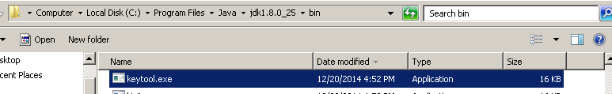

So we have to move and run the following commands under bin directory as keytool.exe file is available in the bin folder.

the following command create a key store file called "testSSLV2.jks"

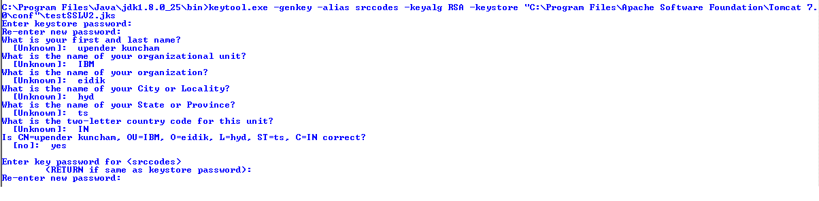

After creating key store we to import the certificate to the key store.

To import we need a certificate, before importing we need to create a self-signed certificate, or we can use any certificate from authorized certificate authority.

I have created self-signed certificate using ikeyman.exe, which is available with IBM products.

In this example i have taken ikeyman.exe from IBM websphere MQ.

steps:

-->go to installed location of the any product,go to jre>bin folder,there you will find ikeyman.exe.

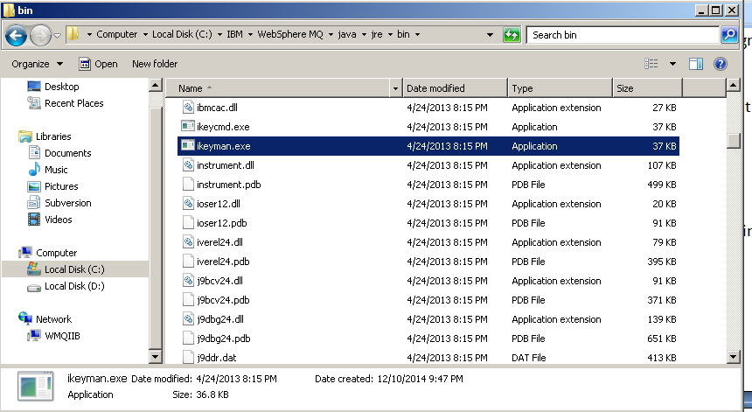

-->double-click on it u will get following window.

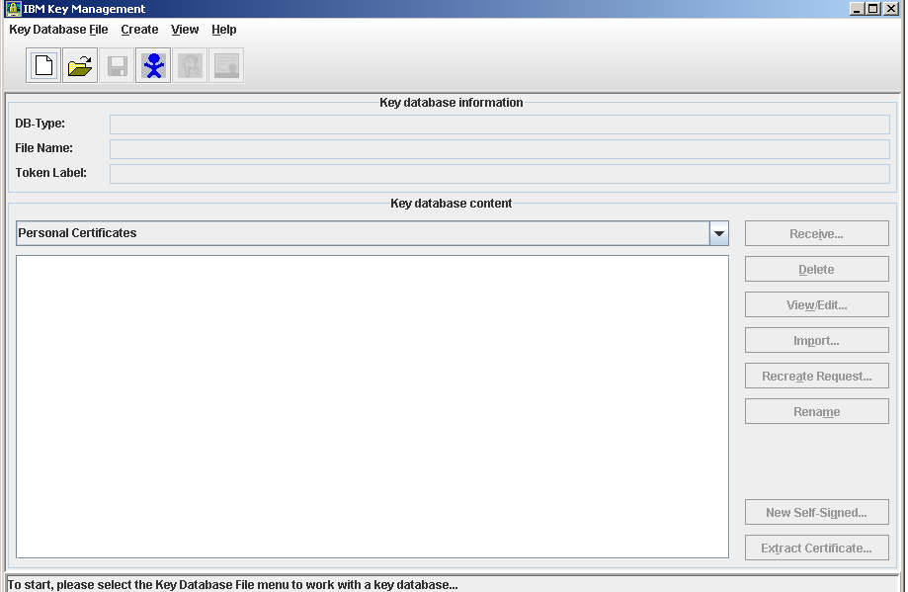

In this window it will not directly allow us to create self-signed certificate, first we have to create a key store and then it allow us to create the certificate, however we will use the previously created key store

using command prompt, using keytool.exe[java home>jdk>bin]

click on "create a new key database file" as bolow.

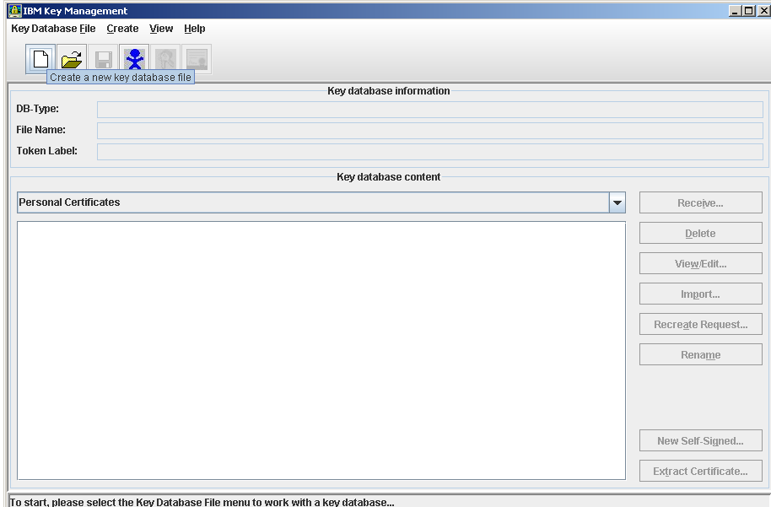

when you click on it the following window will be opened.

by default the following details you can see.

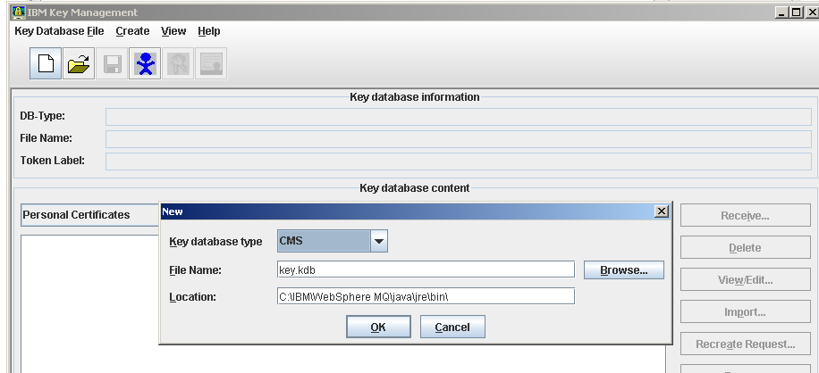

just dropdown key database type and select "jks"type instead CMS, then you can see the file name as key.jks and browse the location where you want to place the key store file. as shown below

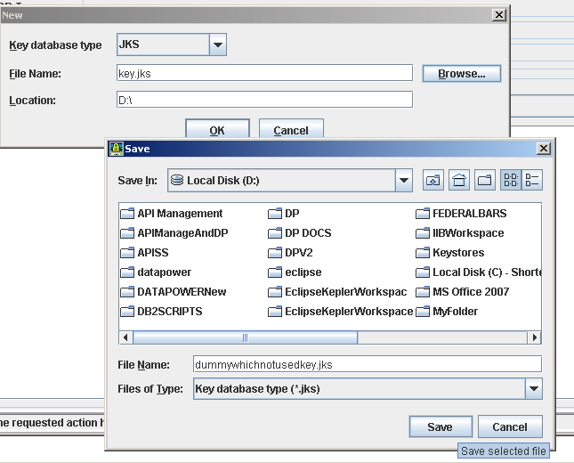

**click on save,now the will be saved under D: /,and then click on OK.**

**after that it will ask the password for keystore as shown in below.**

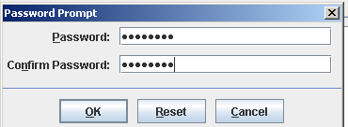

**click on OK.Now keystore has been created,now we can now create self-signed certificate.**

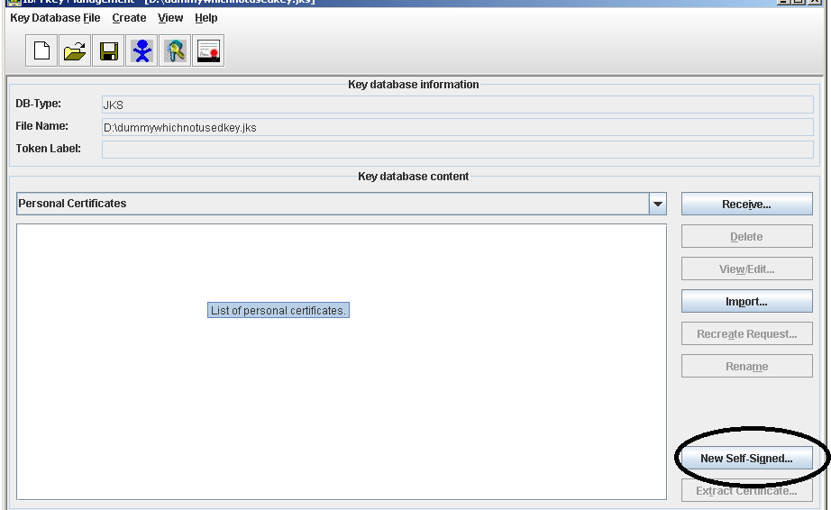

**click on new self -signed as shown in above. the following window opens, please provide the details as**

**below.**

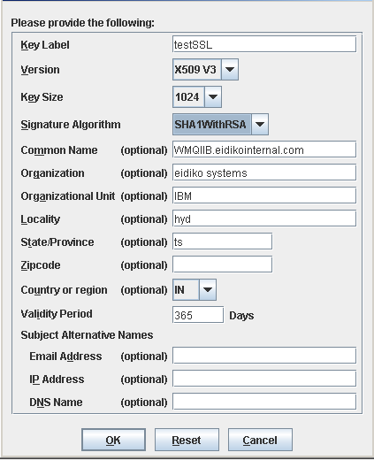

**click on ok. After that click on "extract certificate" to extract the certificate from key store to be used for previously created key store called** testSSLV2.jks.you will see the following window when you click on extract certificate.

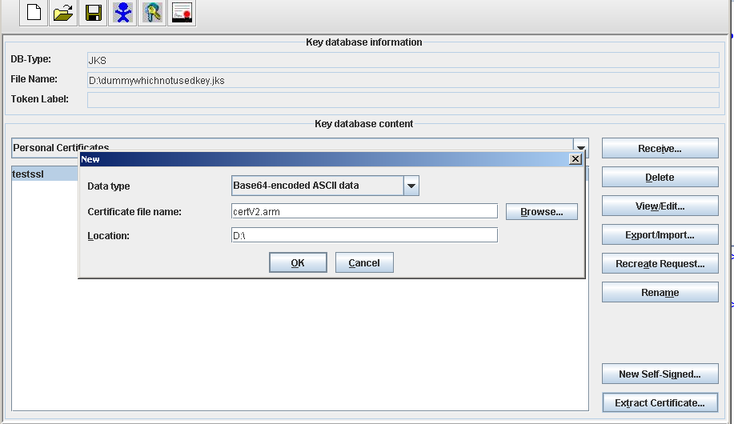

**Now the certificate extracted and saved as "cert.arm" under D:/ ,click on ok.**

**Now we can make use of the certificate, in the following way.**

**Now we have to import this certificate to the key store that we have created using key tool in the following way.**

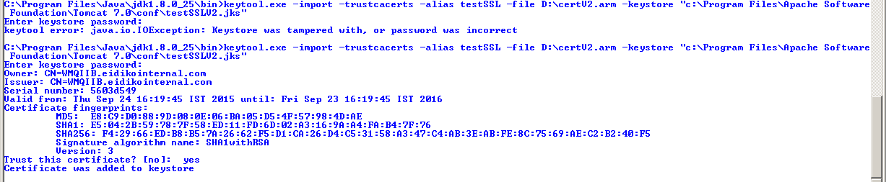

Now the certificate was added to keystore.

Next we have to configure few things in tomcat server.xml file as shown in below.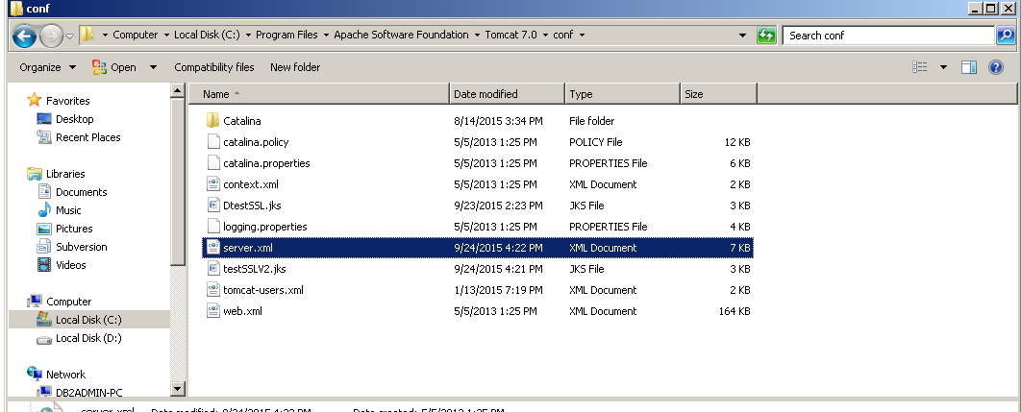

open server.xml with any editor to configure fe things as below.

in default server.xml you will like this.

<!--

<Connector port="8443" protocol="org.apache.coyote.http11.Http11Protocol"

maxThreads="150" SSLEnabled="true" scheme="https" secure="true"

clientAuth="false" sslProtocol="TLS" />

-->

but to enable SSL we have to uncomment and do the following changes.

After un commenting we have to add we have to include following attributes

1)keystore file location

2)keystore alias name which we have given while creating it.

3)keystore type

4)keystore password.

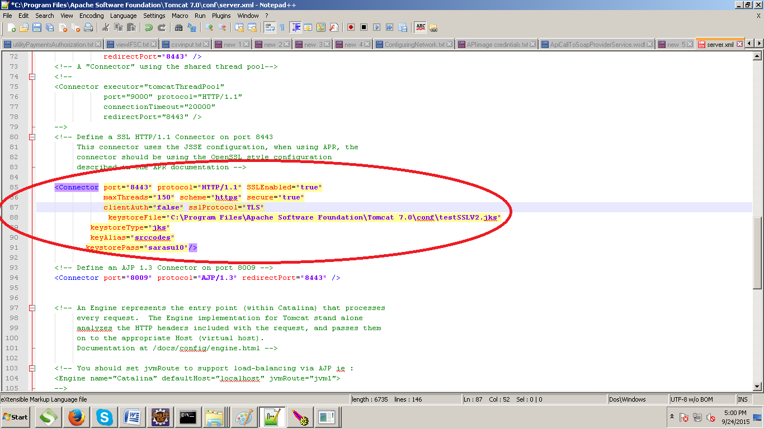

Now save the server.xml file and start the tomcat server,if already started please restart to effect the changes.

now please check whether ssl is configured correctly or not.

go to the browser and type

https://localhost:8443

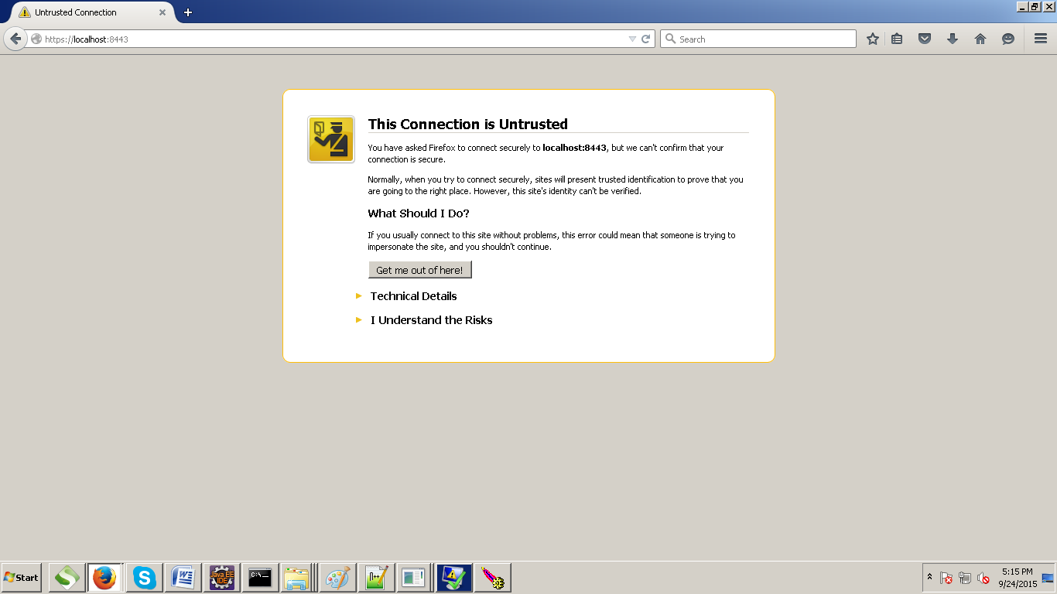

click on i understand the risks>Add exception>

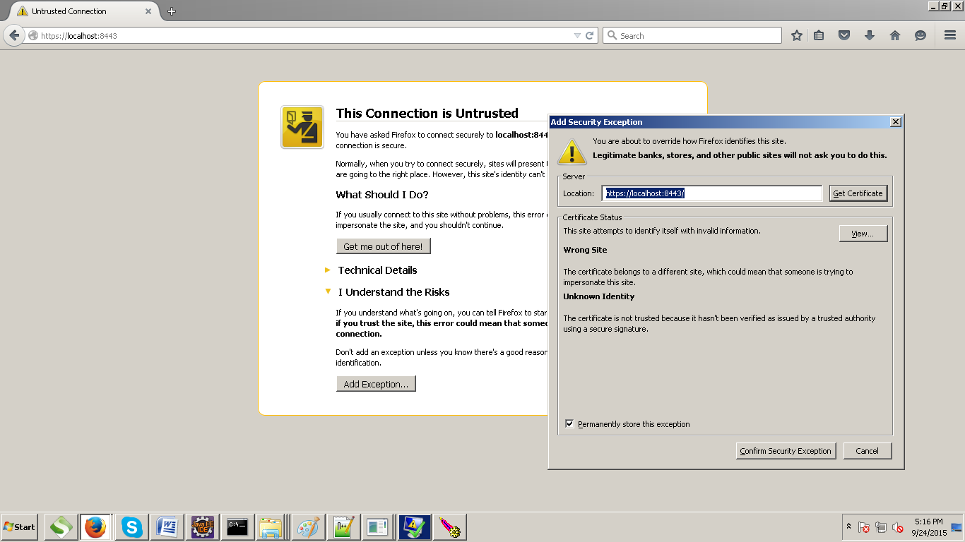

click on the confirm security Exception.

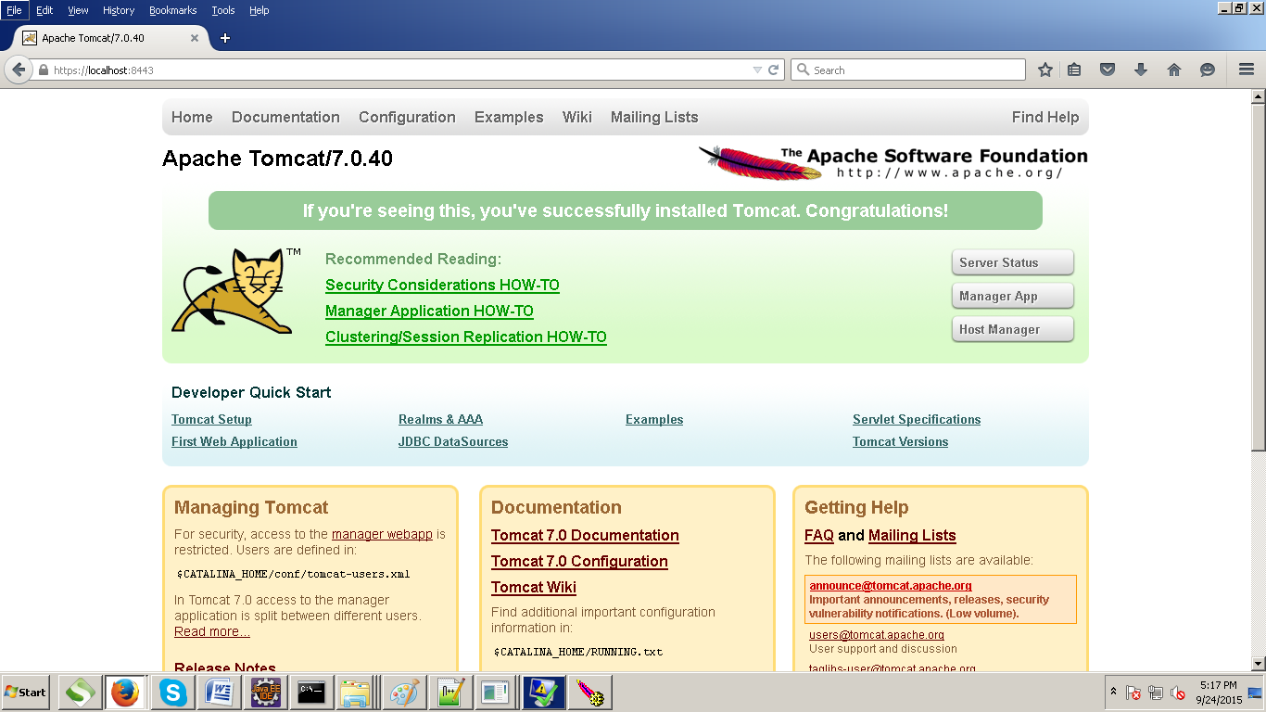

Now we got the secured home page ,so that we can conclude that ssl is confired correctly.

Note: during this process anywhere if you get a permission denied error, please provide permissions to the respected folder or a file.